**Continuous integration (CI):**

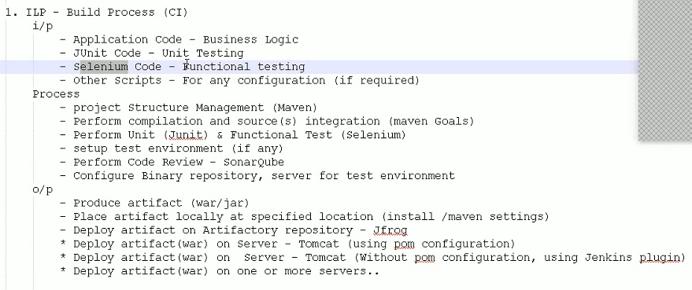

* Go to home directory, open eclipse folder and run the application
* Eclipse has been configured with the maven plugin



* We can create the maven project in eclipse by selecting the archetype

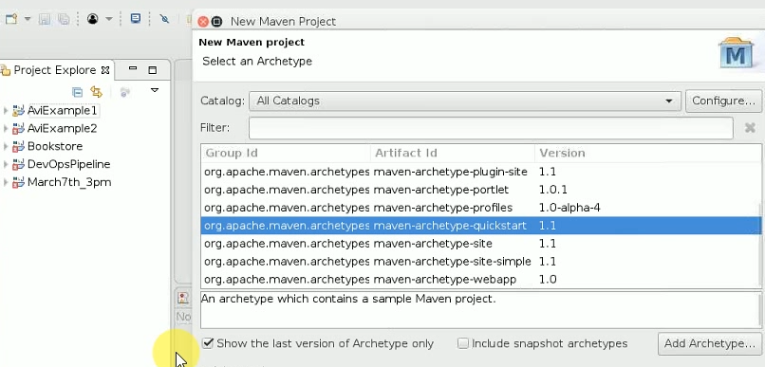

* Then give groupid and artfactid and finish

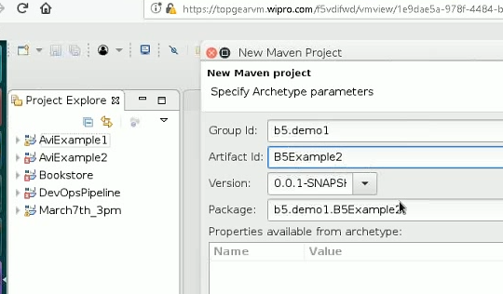

* After this, it will automatically generate the folder. We can see them in left hand side
* We can run the job by giving right click on the project and select the type of build
* It uses sure fire plugin for testing.
* Absolute path means from the root path and relative path means from the project path as below

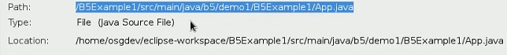

* Default code means business logic and unit test code
* In maven home directory, under conf folder, we can find settings.xml file, in that we can see the default location. If we want, we can change it in local repo by giving the path

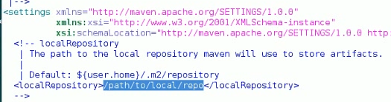



* Even while creating the maven project, it will ask for the default workspace, if we want we can give any other location

**Unit testing:**

* Junit framework
* It simplifies the code
* Testing means it test the output for input
* We can use selenium for python also
* Dependency script in pom.xml

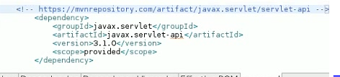

**Functional/integration testing – selenium:**

* Basically, it is used for HTTP request and HTTP responses
* We can integrate within the maven or Jenkins



* We can follow different approaches



**Deployment with maven:**

* We can change port number in setting.xml under “conf” folder

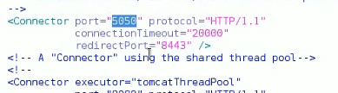

* We can configure manager credentials in tomcat-users.xml under conf folder

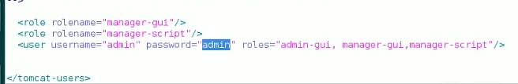

* If we want to deploy automatically, we need to configure in pom.xml as below

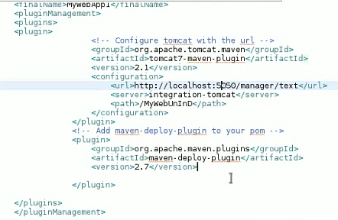

* Server name is optional, and path is the name which we want to give
* For deploying, we need to use tomcat plugin under build section as below

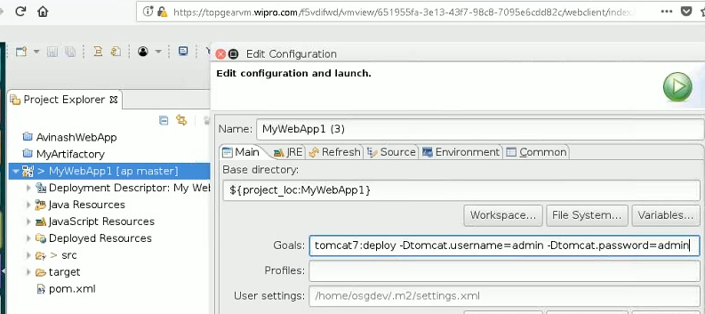

* If we run that, it will build and deploy on tomcat server. We can check that in tomcat
* This we did it through eclipse, we can copy the location and do it in CUI also
* Tomcat is not only web server but also app server
* We can create a Jenkins job (maven project) with git local repo and build triggers as below

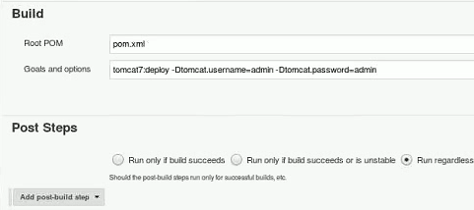

* We can build now from here also
* Or else we can build as below also

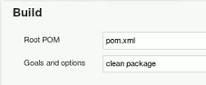

* Go for deployment in post build actions, copy the artifactory url and refresh it

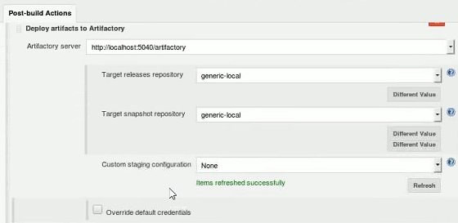

* Download below plugin



* And under again create one more post build action to deploy the war on container
* As below, we can give any name for context, then add tomcat version, credentials and the tomcat URL

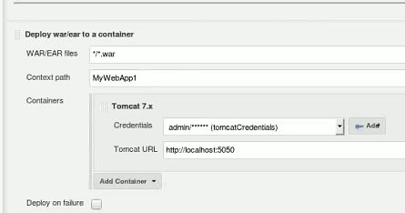

* Integration test happens between package and install



* If the test folder has either unit or functional testing, it does that with package command
* If we go and check the console output, it is not only deploying the war file, but also deploying the pom file which contains the specifications
* To work with a selenium, we need selenium dependency. So add the selenium dependency as below

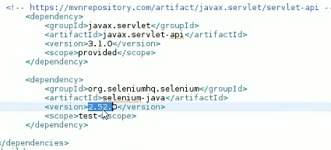

* We can create a separate folder for integration testing

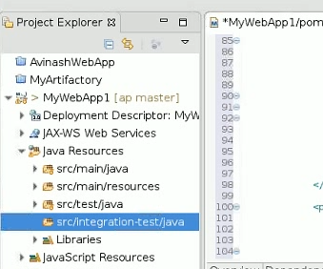

* We can use one or more plugins inside pom.xml

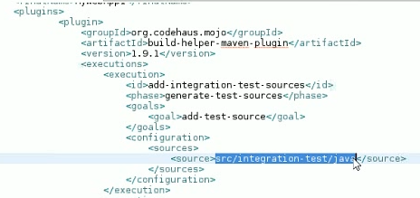

* Org.codehaus plugin is used to recognise integration test files
* For this plugin, we can add how does the execution has to be performed
* For that as above, we have specified add as a test source for the specified source of test file

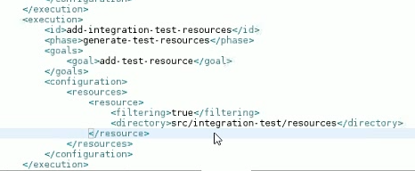

* Like that we can add execution of source to perform

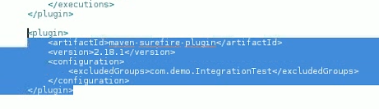

* Surefire plugin is used to perform the test
* These two plugins used to recognise the test resources and perform the operation

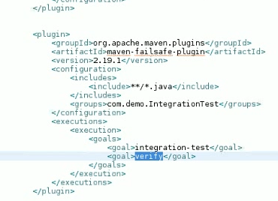

* Above plugin is used to include one or more java files and set a goal to verify, with this we can redeploy easily as it stops the old one

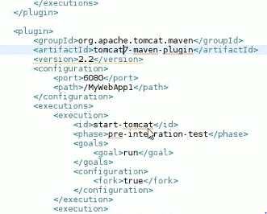

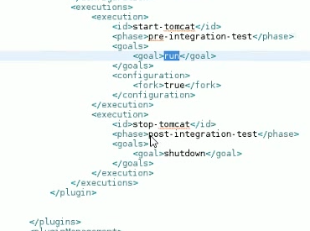

* With the above, we configured to run pre-integration testing and shutdown post integration testing
* All these are set for selenium test inside the maven
* Whatever the plugin we use in maven, it has to be in line





* For unit testing, it doesn’t require any server

